**[ VII ] 스마트폰과 태블릿 레이아웃**

1. 스마트폰 레이아웃
   1. viewport ; 웹브라우저의 HTML문서에 특정한 정보를 나타내기 위한 태그로 meta 태그가 있습니다. 스마트폰 단말기의 화면이 작던 크던 항상 꽉 차게 보여진다. 그래서 디바이스의 특정정보를 나타내기 위해, 모바일 웹브라우저에서는 브라우저의 화면 설정과 관련된 정보를 제공하기 위한 방법 뷰포트 meta 태그를 사용 합니다. 뷰폰트의 속성은 다음과 같습니다
      * 뷰포트 속성들
      * width : 화면의 너비
      * height : 화면의 높이
      * initial-scale : 초기 확대 비율
      * user-scalable : 확대 및 축소 가능 여부
      * minimum-scale : 최소 비율
      * maximum-scale : 최대 비율
   2. header 제작
   3. 네비 제작
   4. 본문 제작 : 본문에 해당하는 section 레이아웃을 만들어 봅니다
   5. Footer의 레이아웃
   6. 기본 스마트폰 레이아웃
2. 스마트 폰 레이아웃 응용 예제 ex01.html

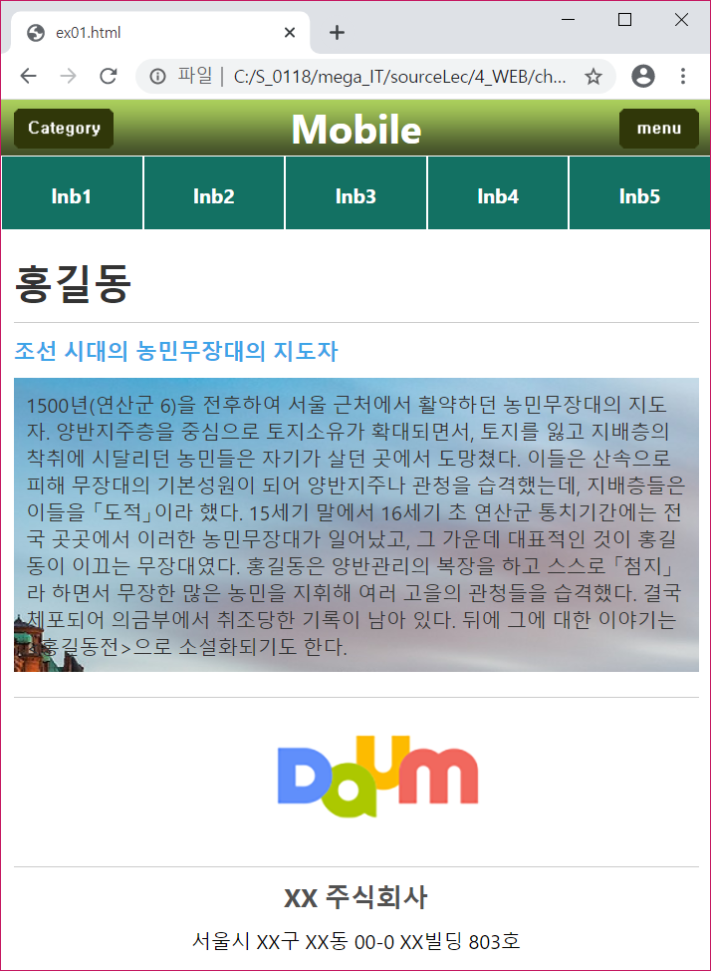 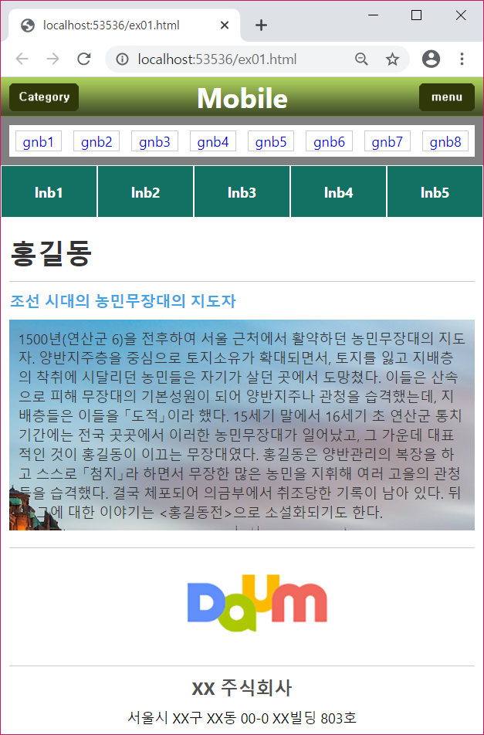

<!DOCTYPE html>

<html lang="en" xmlns="http://www.w3.org/1999/xhtml">

<head>

<meta charset="utf-8" name="viewport"

content="width=device-width,initial-scale=1.0,

minimum-scale=1.0, user-scalable=no"/>

<title></title>

<style>

/* ★ ★ ★ 페이지 초기화 ★ ★ ★*/

*{margin:0; padding:0; font-family:'Segoe UI','Franklin Gothic';}

li{list-style:none;}

a {text-decoration:none;}

/* ★ ★ ★ header ★ ★ ★*/

header#header{

height:45px; line-height:45px; text-align:center;

background-image:url('imgEx01/bg_header.png');

position:relative;

}

#header .left {position:absolute; left:10px; top:7px;}

#header .right{position:absolute; right:10px; top:7px;}

#header > h1 {color:white;}

/* ★ ★ ★ gnb 디자인과 toggle 연동 ★ ★ ★ */

#gnb ul{overflow:hidden; border:10px solid gray;}

#gnb ul li{float:left; width:10%; margin:1.25%;

border:1px solid #cccccc; box-sizing:border-box;

text-align:center;

}

#gnb {display:none;}

#toggle:checked ~ #gnb {display:block;}

#toggle {display:none;}

/* ★ ★ ★ lnb ★ ★ ★ */

#lnb ul{overflow:hidden;}

#lnb ul li{float:left;

width:20%; background-color:#137163;

border:1px solid white;

box-sizing:border-box;

height:60px; line-height:60px; text-align:center;

font-weight: bold;

}

#lnb ul li a {color:white;}

/* ★ ★ ★ #section ★ ★ ★ */

#section {padding:10px; color:#333333;}

#section #section_header{

padding: 10px 0;border-bottom:1px solid #cccccc;

}

#section #section_body p:nth-child(1){

color:#3da4e8; font-weight:bold; font-size:1.1em;

padding: 10px 0;

}

#section #section_body p:nth-child(2){

/*background-image:url('imgEx01/bg_image.jpg');

background-repeat:no-repeat;

background-position: -500px 0;*/

background:url('imgEx01/bg_image.jpg') no-repeat -500px 0;

padding: 10px;

}

/* ★ ★ ★ #footer ★ ★ ★ */

#footer{margin-top:10px;}

#footer .logo{

border-top:1px solid #cccccc;

border-bottom:1px solid #cccccc;

text-align:center;

margin: 0 10px;

}

#footer .logo img{width:250px;}

#footer .info{

text-align:center; font-size:1.3em;

padding:10px 0;

color:#515151; font-weight:bold;

}

#footer .address{text-align:center;}

</style>

</head>

<body>

<input type="checkbox" id="toggle"/>

<header id="header">

<a class="left" href="#">

<img src="imgEx01/category.png" />

</a>

<h1>Mobile</h1>

<label for="toggle" class="right">

<img src="imgEx01/menu.png" />

</label>

</header>

<div id="gnb">

<ul>

<li><a href="#">gnb1</a></li>

<li><a href="#">gnb2</a></li>

<li><a href="#">gnb3</a></li>

<li><a href="#">gnb4</a></li>

<li><a href="#">gnb5</a></li>

<li><a href="#">gnb6</a></li>

<li><a href="#">gnb7</a></li>

<li><a href="#">gnb8</a></li>

</ul>

</div>

<div id="lnb">

<ul>

<li><a href="#">lnb1</a></li>

<li><a href="#">lnb2</a></li>

<li><a href="#">lnb3</a></li>

<li><a href="#">lnb4</a></li>

<li><a href="#">lnb5</a></li>

</ul>

</div>

<div id="section">

<div id="section_header">

<h1>홍길동</h1>

</div>

<div id="section_body">

<p>조선 시대의 농민무장대의 지도자</p>

<p>

1500년(연산군 6)을 전후하여 서울 근처에서 활약하던 농민무장대의 지도자. 양반지주층을 중심으로 토지소유가 확대되면서, 토지를 잃고 지배층의 착취에 시달리던 농민들은 자기가 살던 곳에서 도망쳤다. 이들은 산속으로 피해 무장대의 기본성원이 되어 양반지주나 관청을 습격했는데, 지배층들은 이들을 「도적」이라 했다. 15세기 말에서 16세기 초 연산군 통치기간에는 전국 곳곳에서 이러한 농민무장대가 일어났고, 그 가운데 대표적인 것이 홍길동이 이끄는 무장대였다. 홍길동은 양반관리의 복장을 하고 스스로 「첨지」라 하면서 무장한 많은 농민을 지휘해 여러 고을의 관청들을 습격했다. 결국 체포되어 의금부에서 취조당한 기록이 남아 있다. 뒤에 그에 대한 이야기는 <홍길동전>으로 소설화되기도 한다.

</p>

</div>

</div>

<footer id="footer">

<div class="logo">

<img src="https://t1.daumcdn.net/daumtop_chanel/op/20170315064553027.png" />

</div>

<div class="info">XX 주식회사</div>

<div class="address">서울시 XX구 XX동 00-0 XX빌딩 803호</div>

</footer>

</body>

</html>

1. 스마트 폰 레이아웃 응용 예제 ex02.html

(**F12 후 Ctrl+shift+m 스마트폰이나 태블릿 화면**)

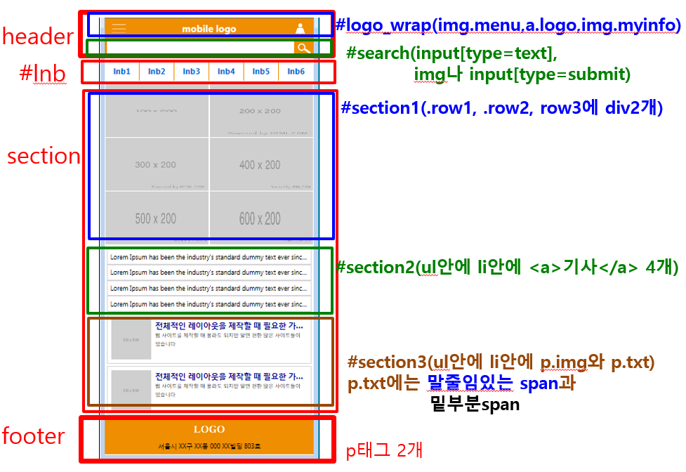

<!DOCTYPE html>

<html lang="en" xmlns="http://www.w3.org/1999/xhtml">

<head>

<meta charset="utf-8" name="viewport"

content="width=device-width, initial-scale=1.0"/>

<title></title>

<style>

/* * * * * * * * * 페이지 초기화 * * * * * * * * */

*{margin:0; padding:0;font-family:'Segoe UI', Tahoma, Geneva, Verdana, sans-serif;}

li{list-style:none;}

a{text-decoration:none;}

img {border: 0;}

/* * * * * * * * * header #logo_wrap * * * * * * * * */

header {height:100px; background-color:#ea8f00;}

header #logo_wrap{height:50px; line-height:50px; text-align:center;

position:relative;

}

header #logo_wrap .menu{position:absolute; left:10px; top:0;}

header #logo_wrap .myinfo{position:absolute; right:10px; top:0;}

header #logo_wrap a.logo{font-size:1.5em; font-weight:bold; color:white;}

/* * * * * * * * * header #search * * * * * * * * */

header #search{position:relative;}

header #search input[type=text]{

width:100%; height:50px; line-height:50px;

border:5px solid #ea8f00;

box-sizing:border-box;

font-size:1.2em;

padding:5px 55px 5px 5px;

outline:none;

}

header #search img{position:absolute; right:0; top:0;}

/* * * * * * * * * #lnb * * * * * * * * */

#lnb ul{overflow:hidden; margin:7px 0;}

#lnb ul li{

float:left; width:16.66666%; height:50px; line-height:50px; text-align:center;

border-right:1px solid #ea8f00;

box-sizing:border-box;

}

#lnb ul li:last-child{border:0;}

#lnb ul li a {display:block;font-size:1.3em;font-weight:bold;}

/* * * * * * * * * section #section1 * * * * * * * * */

section #section1 .row1, section #section1 .row2, section #section1 .row3 {

overflow: hidden;

}

section #section1 .row1 div,

section #section1 .row2 div,

section #section1 .row3 div {

float: left; width: 50%; height: 135px;

border: 1px solid white; box-sizing: border-box;

}

section #section1 img{width:100%; height:100%;}

/* * * * * * * * * section #section2 * * * * * * * * */

section #section2{margin:10px 5px;}

section #section2 ul li{

padding:8px; border:1px solid lightgray;

/*말줄임(ellipsis) 태그*/

white-space:nowrap; overflow:hidden; text-overflow:ellipsis;

}

section #section2 a{color:black;}

/* * * * * * * * * section #section3 * * * * * * * * */

section #section3 ul li {

overflow: hidden;

border: 1px solid lightgray;

margin: 5px;

padding: 10px;

}

section #section3 ul li p.img{float:left; width:20%; margin-right:3%;}

section #section03 ul li p.img img{width:100%; height:100%;}

section #section3 ul li p.txt{float:left;width:77%;}

section #section3 ul li p.txt span:first-child{

color:darkblue; font-weight:bold; font-size:1.2em;

display:block;

/*말줄임(ellipsis) 태그*/

white-space:nowrap; overflow:hidden; text-overflow:ellipsis;

}

section #section3 ul li p.txt span:last-child{

font-size:.8em;

}

/* * * * * * * * * footer * * * * * * * * */

footer{background-color:#ea8f00; text-align:center;}

footer p:nth-child(1){padding:5px;}

footer p:nth-child(2){height:30px; line-height:20px;}

</style>

</head>

<body>

<header>

<div id="logo_wrap">

<img src="imgEx02/menu.png" class="menu"/>

<a href="ex02.html" class="logo">mobile logo</a>

<img src="imgEx02/myinfo.png" class="myinfo" />

</div>

<div id="search">

<input type="text" name="query_word" />

<img src="imgEx02/search.png" />

</div>

</header>

<div id="lnb">

<ul>

<li><a href="#">lnb1</a></li><li><a href="#">lnb2</a></li>

<li><a href="#">lnb3</a></li><li><a href="#">lnb4</a></li>

<li><a href="#">lnb5</a></li><li><a href="#">lnb6</a></li>

</ul>

</div>

<section>

<div id="section1">

<div class="row1">

<div><a href="#a1"><img src="http://placehold.it/100x200" alt="1행1열" /></a></div>

<div><a href="#a2"><img src="http://placehold.it/200x200" alt="1행2열" /></a></div>

</div>

<div class="row2">

<div><a href="#a2"><img src="http://placehold.it/300x200" alt="1행1열" /></a></div>

<div><a href="#a1"><img src="http://placehold.it/400x200" alt="1행2열" /></a></div>

</div>

<div class="row3">

<div><a href="#a1"><img src="http://placehold.it/500x200" alt="1행1열" /></a></div>

<div><a href="#a2"><img src="http://placehold.it/600x200" alt="1행2열" /></a></div>

</div>

</div>

<div id="section2">

<ul>

<li><a href="#">Lorem Ipsum has been the industry's standard dummy text ever since the 1500s, when an unknown printer took a galley of type and scrambled it to make a type specimen book</a></li>

<li><a href="#">Lorem Ipsum has been the industry's standard dummy text ever since the 1500s, when an unknown printer took a galley of type and scrambled it to make a type specimen book</a></li>

<li><a href="#">Lorem Ipsum has been the industry's standard dummy text ever since the 1500s, when an unknown printer took a galley of type and scrambled it to make a type specimen book</a></li>

<li><a href="#">Lorem Ipsum has been the industry's standard dummy text ever since the 1500s, when an unknown printer took a galley of type and scrambled it to make a type specimen book</a></li>

</ul>

</div>

<div id="section3">

<ul>

<li>

<p class="img"><a href="#"><img src="http://placehold.it/100x100" /></a></p>

<p class="txt">

<span>전체적인 레이아웃을 제작할 때 필요한 가상의 이미지</span>

<span>웹 사이트를 제작할 때 몰라도 되지만 알면 편한 많은 사이트들이 있습니다</span>

</p>

</li>

<li>

<p class="img"><a href="#"><img src="http://placehold.it/100x100" /></a></p>

<p class="txt">

<span>전체적인 레이아웃을 제작할 때 필요한 가상의 이미지</span>

<span>웹 사이트를 제작할 때 몰라도 되지만 알면 편한 많은 사이트들이 있습니다</span>

</p>

</li>

</ul>

</div>

</section>

<footer>

<p><img src="imgEx02/logo.png" /></p>

<p>서울시 XX구 XX동 000 XX빌딩 803호</p>

</footer>

</body>

</html>

<!DOCTYPE html>

<html lang="en" xmlns="http://www.w3.org/1999/xhtml">

<head>

<meta charset="utf-8" name="viewport"

content="width=device-width, initial-scale=1.0"/>

<title></title>

<style>

/* * * * * * * * * 페이지 초기화 * * * * * * * * */

*{margin:0; padding:0;font-family:'Segoe UI', Tahoma, Geneva, Verdana, sans-serif;}

li{list-style:none;}

a{text-decoration:none;}

img {border: 0;}

/* * * * * * * * * header #logo_wrap * * * * * * * * */

header {height:100px; background-color:#ea8f00;}

header #logo_wrap{height:50px; line-height:50px; text-align:center;

position:relative;

}

header #logo_wrap .menu{position:absolute; left:10px; top:0;}

header #logo_wrap .myinfo{position:absolute; right:10px; top:0;}

header #logo_wrap a.logo{font-size:1.5em; font-weight:bold; color:white;}

/* * * * * * * * * header #search * * * * * * * * */

header #search{position:relative;}

header #search input[type=text]{

width:100%; height:50px; line-height:50px;

border:5px solid #ea8f00;

box-sizing:border-box;

font-size:1.2em;

padding:5px 55px 5px 5px;

outline:none;

}

header #search img{position:absolute; right:0; top:0;}

/* * * * * * * * * #lnb * * * * * * * * */

#lnb ul{overflow:hidden; margin:7px 0;}

#lnb ul li{

float:left; width:16.66666%; height:50px; line-height:50px; text-align:center;

border-right:1px solid #ea8f00;

box-sizing:border-box;

}

#lnb ul li:last-child{border:0;}

#lnb ul li a {display:block;font-size:1.3em;font-weight:bold;}

/* * * * * * * * * section #section1 * * * * * * * * */

section #section1 .row1, section #section1 .row2, section #section1 .row3 {

overflow: hidden;

}

section #section1 .row1 div,

section #section1 .row2 div,

section #section1 .row3 div {

float: left;

width: 50%;

height: 135px;

border: 1px solid white;

box-sizing: border-box;

}

section #section1 img{width:100%; height:100%;}

/* * * * * * * * * section #section2 * * * * * * * * */

section #section2{margin:10px 5px;}

section #section2 ul li{

padding:8px; border:1px solid lightgray;

/*말줄임(ellipsis) 태그*/

white-space:nowrap; overflow:hidden; text-overflow:ellipsis;

}

section #section2 a{color:black;}

/* * * * * * * * * section #section3 * * * * * * * * */

section #section3 ul li {

overflow: hidden;

border: 1px solid lightgray;

margin: 5px;

}

section #section3 ul>li{height:120px; position:relative;}

section #section3 ul li p.img{

width:100px; height:100px;

position:absolute; left:10px; top:10px;

}

section #section3 ul li p.txt {

width:100%-20px;

padding: 10px 20px 10px 120px;

}

section #section3 ul li p.txt span:first-child {

color: darkblue;

font-weight: bold;

font-size: 1.2em;

display: block;

/*말줄임(ellipsis) 태그*/

white-space: nowrap;

overflow: hidden;

text-overflow: ellipsis;

}

section #section3 ul li p.txt span:last-child{

font-size:.8em;

}

/* * * * * * * * * footer * * * * * * * * */

footer {

background-color: #ea8f00;

text-align: center;

}

footer p:nth-child(1) {

padding: 5px;

}

footer p:nth-child(2){height:30px; line-height:20px;}

</style>

</head>

<body>

<header>

<div id="logo_wrap">

<img src="imgEx02/menu.png" class="menu"/>

<a href="ex02.html" class="logo">mobile logo</a>

<img src="imgEx02/myinfo.png" class="myinfo" />

</div>

<div id="search">

<input type="text" name="query_word" />

<img src="imgEx02/search.png" />

</div>

</header>

<div id="lnb">

<ul>

<li><a href="#">lnb1</a></li><li><a href="#">lnb2</a></li>

<li><a href="#">lnb3</a></li><li><a href="#">lnb4</a></li>

<li><a href="#">lnb5</a></li><li><a href="#">lnb6</a></li>

</ul>

</div>

<section>

<div id="section1">

<div class="row1">

<div><a href="#a1"><img src="http://placehold.it/100x200" alt="1행1열" /></a></div>

<div><a href="#a2"><img src="http://placehold.it/200x200" alt="1행2열" /></a></div>

</div>

<div class="row2">

<div><a href="#a2"><img src="http://placehold.it/300x200" alt="1행1열" /></a></div>

<div><a href="#a1"><img src="http://placehold.it/400x200" alt="1행2열" /></a></div>

</div>

<div class="row3">

<div><a href="#a1"><img src="http://placehold.it/500x200" alt="1행1열" /></a></div>

<div><a href="#a2"><img src="http://placehold.it/600x200" alt="1행2열" /></a></div>

</div>

</div>

<div id="section2">

<ul>

<li><a href="#">Lorem Ipsum has been the industry's standard dummy text ever since the 1500s, when an unknown printer took a galley of type and scrambled it to make a type specimen book</a></li>

<li><a href="#">Lorem Ipsum has been the industry's standard dummy text ever since the 1500s, when an unknown printer took a galley of type and scrambled it to make a type specimen book</a></li>

<li><a href="#">Lorem Ipsum has been the industry's standard dummy text ever since the 1500s, when an unknown printer took a galley of type and scrambled it to make a type specimen book</a></li>

<li><a href="#">Lorem Ipsum has been the industry's standard dummy text ever since the 1500s, when an unknown printer took a galley of type and scrambled it to make a type specimen book</a></li>

</ul>

</div>

<div id="section3">

<ul>

<li>

<p class="img"><a href="#"><img src="http://placehold.it/100x100" /></a></p>

<p class="txt">

<span>전체적인 레이아웃을 제작할 때 필요한 가상의 이미지</span>

<span>웹 사이트를 제작할 때 몰라도 되지만 알면 편한 많은 사이트들이 있습니다</span>

</p>

</li>

<li>

<p class="img"><a href="#"><img src="http://placehold.it/100x100" /></a></p>

<p class="txt">

<span>전체적인 레이아웃을 제작할 때 필요한 가상의 이미지</span>

<span>웹 사이트를 제작할 때 몰라도 되지만 알면 편한 많은 사이트들이 있습니다</span>

</p>

</li>

</ul>

</div>

</section>

<footer>

<p><img src="imgEx02/logo.png" /></p>

<p>서울시 XX구 XX동 000 XX빌딩 803호</p>

</footer>

</body>

</html>